**23CSE111**

**OBJECT ORIENTED PROGRAMMING**

**LAB REPORT**



**Department of Computer Science Engineering**

**Amrita School of Computing**

**Amrita Vishwa Vidyapeetham, Amaravati Campus**

**Name:** K. Sai Mahalakshmi

**Roll No:** AV.SC.U4CSE24248

**Verified By:**

**INDEX**

|  |  |  |  |
| --- | --- | --- | --- |
|  |  |  |  |
|  |  |  |  |
|  |  |  |  |
|  |  |  |  |
|  |  |  |  |

**WEEK -1**

**Program -1:**

**Aim:**

Download and Install Java Software

**Procedure:**

**Step-1: Download JDK-21**

* Go to web browser and type Oracle JDK Download.
* Now click on the official website.
* Scroll down to the Java SE Development Kit 21.0.6 downloads section.
* Choose the operating system (macOS, Windows, Linux).
* Click on Download, then wait for the download to complete.

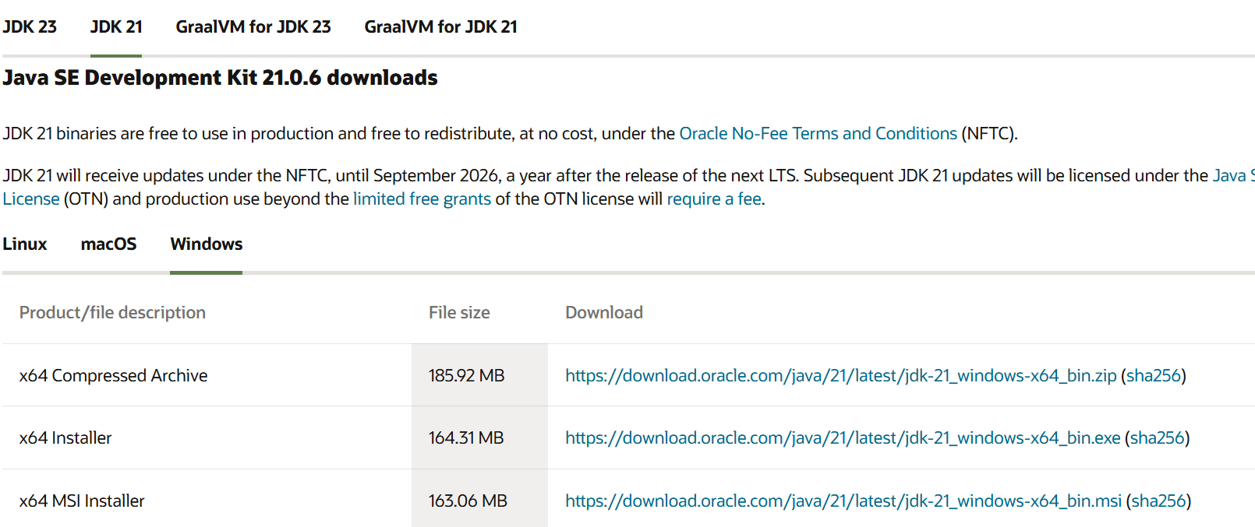

**Step 2:** **Install JDK 21**

* Locate the downloaded jdk-21_windows-x64_bin.exe file.
* Double-click to launch the installer.
* Click Next on the setup wizard.
* Choose the installation path (default is C:\Program Files\Java\jdk-21).
* Click Next, then click Install, wait for the installation to complete.
* Click Close once the installation is finished.

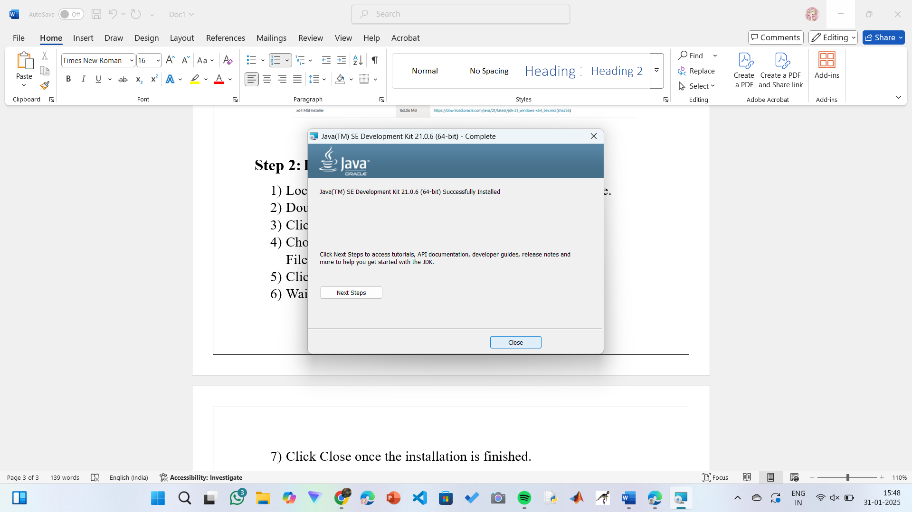

**Step 3: Setting up the path**

* Go to “Windows C” Drive on Desktop.
* Choose Program Files, select Java, then JDK 21, then select Bin.
* Select and copy the path at the address bar.

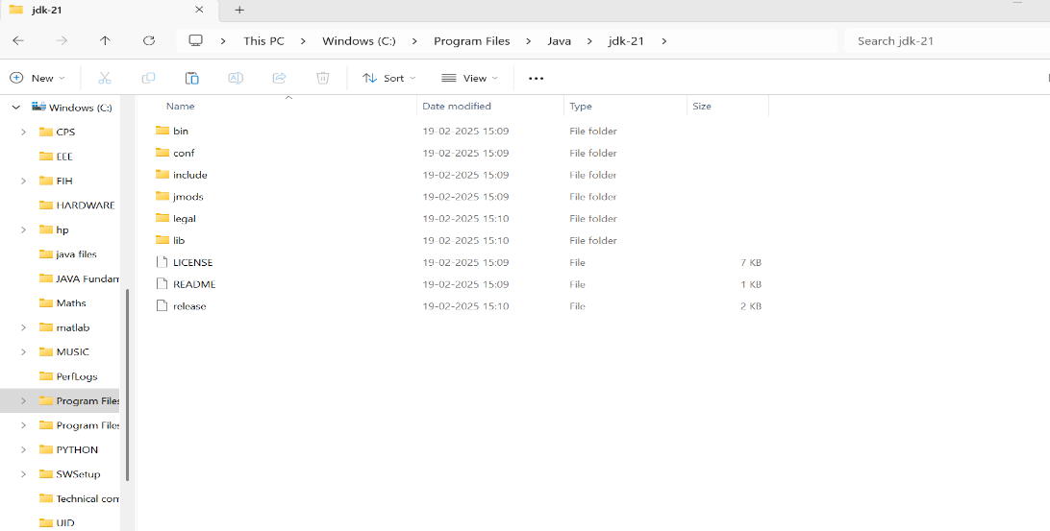

**Step 4: Open System Properties**

* Open file explorer, then right click on This PC.
* Next select on properties then it will take you to the settings app.
* Click on Advanced tab.
* Click on Environment Variables at the bottom.

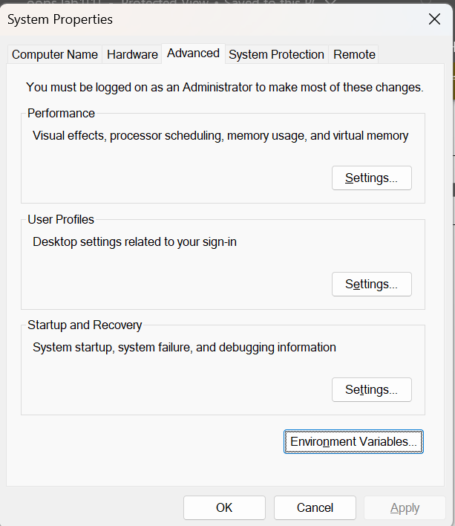

**Step 5: Set JAVA_HOME**

* Under System Variables, click New.
* Set the Variable name as JAVA_HOME.
* Set Variable value as C:\Program Files\Java\jdk-21 (or your installation path).
* Click OK.

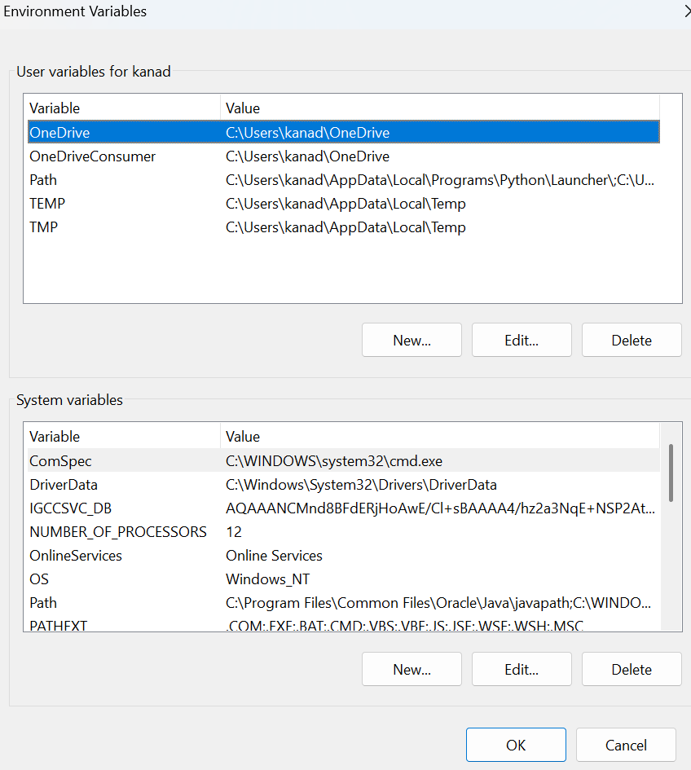

**Step 6: Update PATH Variable**

* In System Variables, find Path and click Edit.
* Click New and add: C:\Program Files\Java\jdk-21\bin.
* Click OK to save.

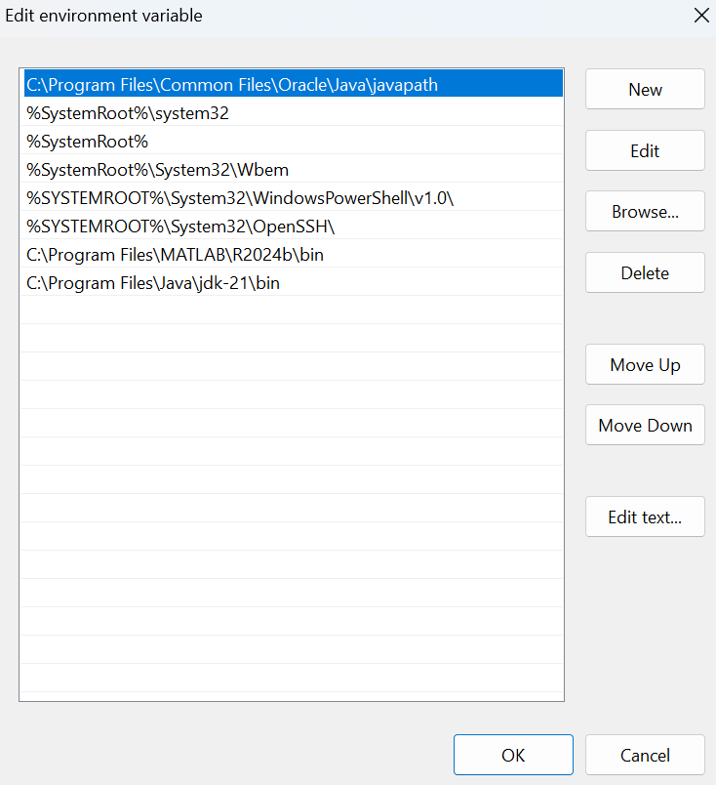

**Step 7:Verify Installation**

* Open Command Prompt.
* Type the following command: **java --version** and press Enter.

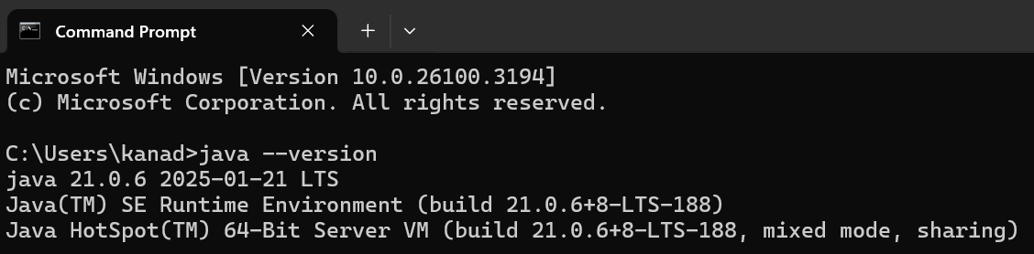

* To check the java compiler type: **javac --version.**

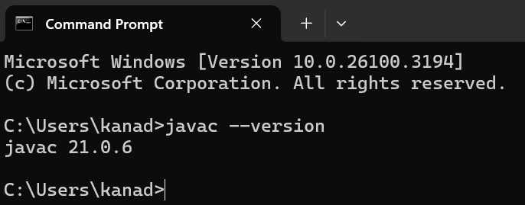

**Program-2:**

**Aim:**

Write a program that prints Helloworld.

**Code:**

class Helloworld {

public static void main(String[] args) {

System.out.print("Hello World");

}

}

**Output:**

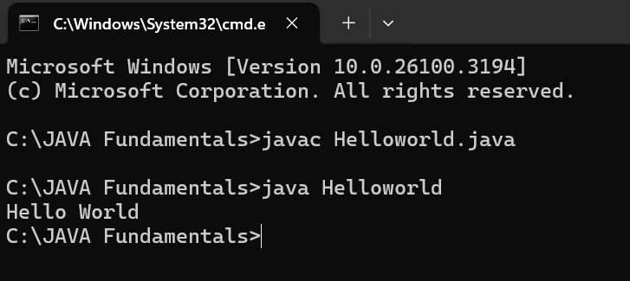

|  |  |
| --- | --- |
| Error Found | Error Rectified |
| None Found | None Rectified |

**Program-3:**

**Aim:**

Write a program that prints Student details.

**Code:**

class Studentdetails {

public static void main(String[] args) {

System.out.println("Name: K. Sai Mahalakshmi");

System.out.println("Branch & Section: CSE-C");

System.out.print("University: Amrita Vishwa Vidyapeetham");

}

}

**Output:**

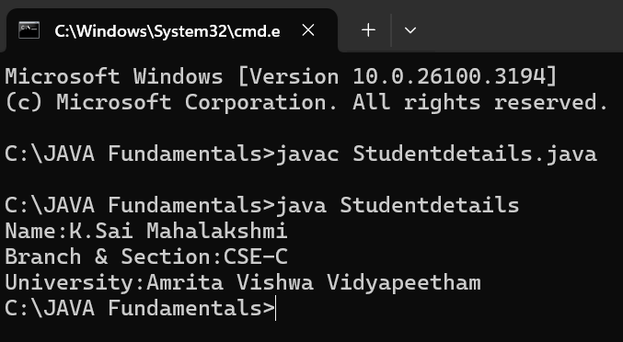

|  |  |
| --- | --- |
| Error Found | Error Rectified |
| The class name should start with capital letter. | I had changed the first letter from small to capital. |

**WEEK-2**

**Program-1:**

**Aim:**

Write a program to calculate area of rectangle.

**Code:**

import java.util.Scanner;

class Area {

public static void main(String[] args) {

Scanner input = new Scanner(System.in);

System.out.print("Enter length: ");

float length = input.nextFloat();

System.out.print("Enter width: ");

float breadth = input.nextFloat();

input.close();

float area = length * breadth;

System.out.println("Area of rectangle: " + area);

}

}

**Positive Output:** 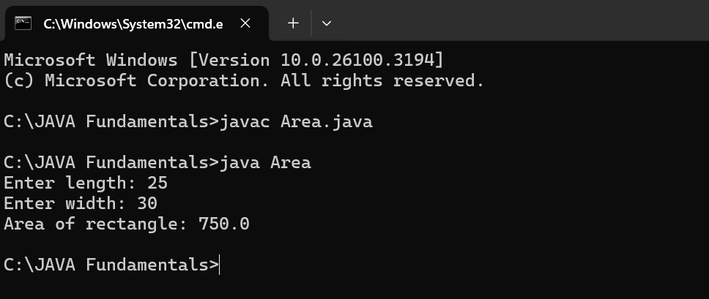

**Negative output:**

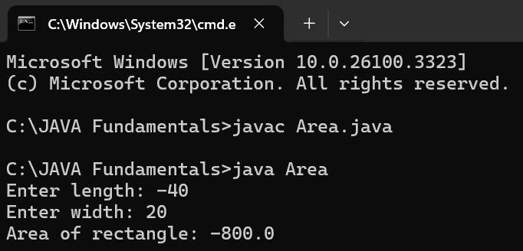

**IMPORTANT POINTS :**

The program uses java.util.Scanner to take input from the user for:

Length of the rectangle.

Breadth of the rectangle.

|  |  |
| --- | --- |
| Error Found | Error Rectified |
| Error: ‘;’ expected | Need to put ‘;’ at the end |

**Program-2:**

**Aim:**

Write a program to convert temperature from fahrenheit to Celsius and vice versa.

**Code:**

import java.util.Scanner;

class Temperature {

public static void main(String[] args) {

Scanner input = new Scanner(System.in);

System.out.print("Enter Temperature in Fahrenheit: ");

float F = input.nextFloat();

input.close();

float C = (F - 32)*5/9;

System.out.println("Temperature in celsius: " + C);

}

}

**Positive Output:**

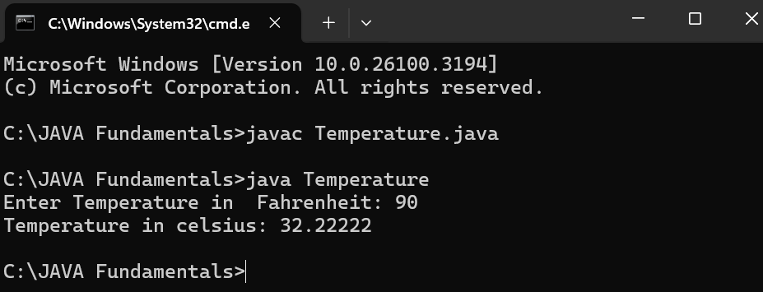

**Negative Output:**

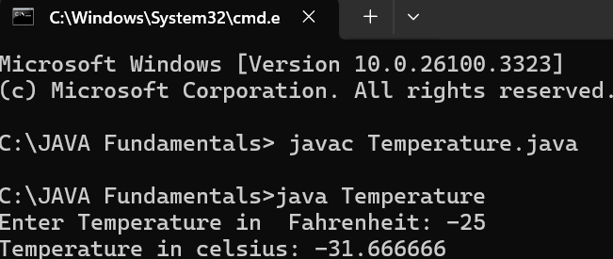

**Code:**

import java.util.Scanner;

class Temperature2 {

public static void main(String[] args) {

Scanner input = new Scanner(System.in);

System.out.print("Enter Temperature in Celsius: ");

float C = input.nextFloat();

input.close();

float F = (C * 9/5) + 32;

System.out.println("Temperature in Fahrenheit: " + F);

}

}

**Positive Output:**

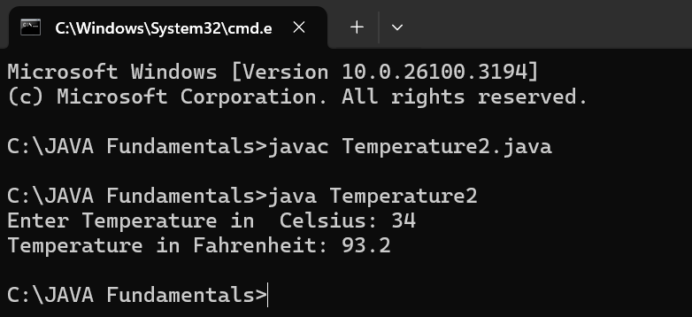

**Negative Output:**

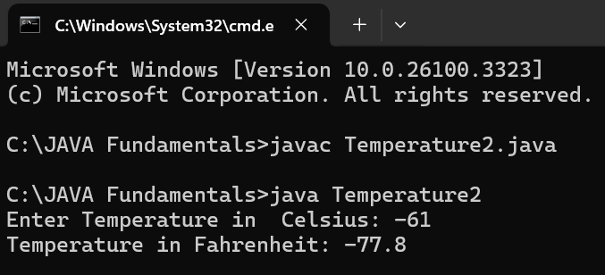

**IMPORTANT POINTS:**

The line “Scanner input = new Scanner(System.in),” tends to create a new Scanner object named “input” that reads input from the standard input stream (System.in), like keyboard.

|  |  |
| --- | --- |
| Error Found | Error Rectified |
| While printing the variable not giving + sign. | We should give correct indentation. |

**Program-3:**

**Aim:**

Write a program to calculate simple interest.

**Code:**

import java.util.Scanner;

class Simple_interest {

public static void main(String[] args) {

Scanner input = new Scanner(System.in);

System.out.print("Enter principle: ");

float p = input.nextFloat();

System.out.print("Enter time: ");

float t = input.nextFloat();

System.out.print("Enter rate: ");

float r = input.nextFloat();

input.close();

float SI = (p*t*r)/100;

System.out.println("Simple Interest : " +SI );

}

}

**Positive Output:**

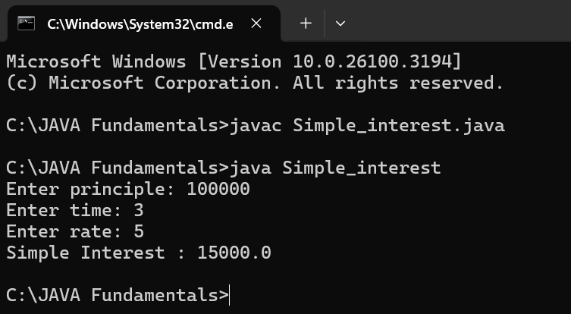

**Negative Output:**

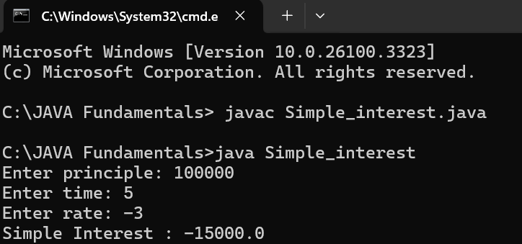

**IMPORTANT POINTS:**

line “import java.util.Scanner” indicates:

Import: tells the java compiler that we want to use a specific class in code.

Java.util : It contains utility classes for Java programming.

Scanner: It is the class that allows you to read input from the keyboard.

|  |  |
| --- | --- |
| Error Found | Error Rectified |
| The class name should start with capital letter | I had changed the first letter from small to capital. |

**Program-4:**

**Aim:**

Write a program to calculate Area of triangle.

**Code:**

public class Areaoftriangle {

public static void main(String[] args) {

double s1, s2, s3;

double area, resArea;

s1 = 25.0;

s2 = 30.0;

s3 = 5.0;

area = (s1+s2+s3)/2.0d;

resArea = Math.sqrt(area* (area - s1) * (area - s2) * (area - s3));

System.out.println("Area of Triangle = " + resArea);

}

}

**Output:**

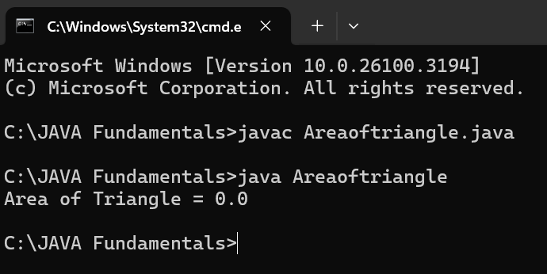

**IMPORTANT POINTS:**we’re finding the area of a triangle using heron’s formula.

S is the semi-parameter of the triangle.

|  |  |
| --- | --- |
| Error Found | Error Rectified |
| Error: Double s1, s2, s3;  ^ | Rectified: double s1,s2,s3; |

**Program-5:**

**Aim:**

Write a program to calculate Factorial of a number.

**Code:**

import java.util.Scanner;

public class Factorial {

public static void main(String[] args) {

Scanner input = new Scanner(System.in);

System.out.print("Enter number: ");

int n = input.nextInt();

input.close();

long factorial = 1;

for (int i = 1; i <= n; i++) {

factorial*= i;

}

System.out.println("Factorial of " + n + " is: " + factorial);

}

}

**Positive Output:**

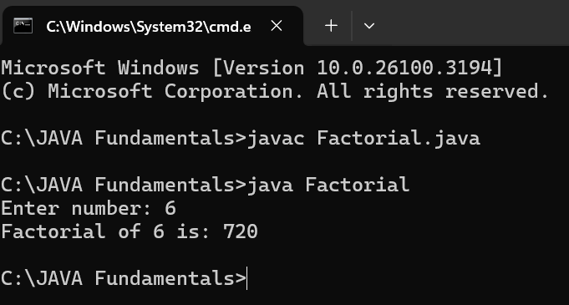

**Negative Output:**

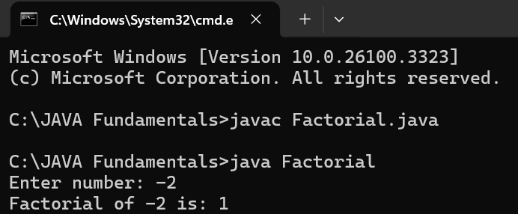

**IMPORTANT POINTS:**

The factorial of n is calculated using a for loop.

we are using the data type “int” just to calculate the integer values and it doesn’t support floating points.

|  |  |
| --- | --- |
| Error Found | Error Rectified |
| System.out.print(Enter number: ): “ ” ,’;’expected; | System.out.print(“Enter number:” ); |

**Program-6:**

**Aim:**

Write a program to calculate Fibonacci series.

**Code:**

import java.util.Scanner;

public class Fibonacci {

public static void main(String[] args) {

Scanner scanner = new Scanner(System.in);

System.out.print("Enter the number of terms: ");

int terms = scanner.nextInt();

long firstTerm = 0, secondTerm = 1;

System.out.println("Fibonacci Series up to " + terms + " terms:");

for (int i = 1; i <= terms; ++i) {

System.out.print(firstTerm + " ");

long nextTerm = firstTerm + secondTerm;

firstTerm = secondTerm;

secondTerm = nextTerm;

}

}

}

**Positive Output:**

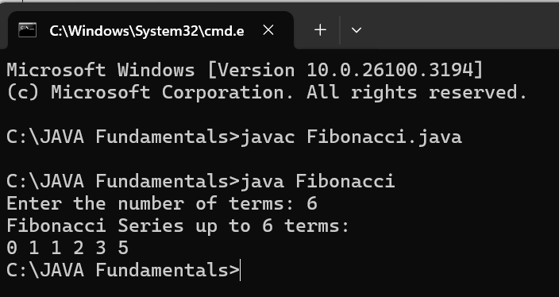

**Negative Output:**

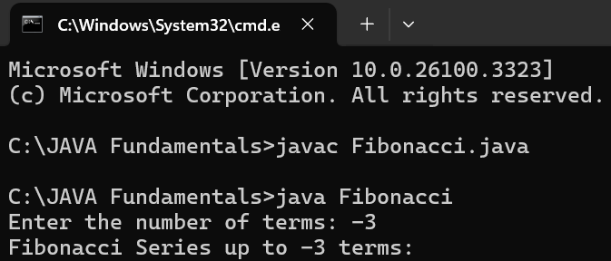

**IMPORTANT POINTS:**

We use while loop in this program.

The process in this program is repeated certain number of times until the conditions meet.

|  |  |
| --- | --- |
| Error Found | Error Rectified |
| Fibonacci.java:12: error: ';' expected | At the end firstTerm = secondTerm should have; |

**WEEK-3**

**1. AIM:**

**To create java program with following instructions:**

Create a class with a name car.

Create four attributes named car_color, car_brand, fuel_type, mileage.

Create three methods named start(), stop(), service().

Create the objects named car1, car2, car3.

**Code:**

public class Car {

private String car_color;

private String car_brand;

private String fuel_type;

private String mileage;

public void start() {

System.out.println("car is started");

}

public void stop() {

System.out.println("car is stopped");

}

public void service() {

System.out.println("car is for service");

}

public static void main(String args[]) {

Car car1 = new Car();

car1.car_color="black";

car1.car_brand="BMW";

car1.fuel_type="diesel";

car1.mileage="20";

car1.start();

car1.stop();

car1.service();

System.out.println("car_color:"+car1.car_color);

System.out.println("car_brand:"+car1.car_brand);

System.out.println("fuel_type:"+car1.fuel_type);

System.out.println("mileage:"+car1.mileage);

Car car2 = new Car();

car2.car_color="white";

car2.car_brand="audi";

car2.fuel_type="petrol";

car2.mileage="20";

car2.start();

car2.stop();

car2.service();

System.out.println("car_color:"+car2.car_color);

System.out.println("car_brand:"+car2.car_brand);

System.out.println("fuel_type:"+car2.fuel_type);

System.out.println("mileage:"+car2.mileage);

Car car3 = new Car();

car3.car_color="white";

car3.car_brand="Benz";

car3.fuel_type="petrol";

car3.mileage="10";

car3.start();

car3.stop();

car3.service();

System.out.println("car_color:"+car3.car_color);

System.out.println("car_brand:"+car3.car_brand);

System.out.println("fuel_type:"+car3.fuel_type);

System.out.println("mileage:"+car3.mileage);

}

}

**Positive Output:**

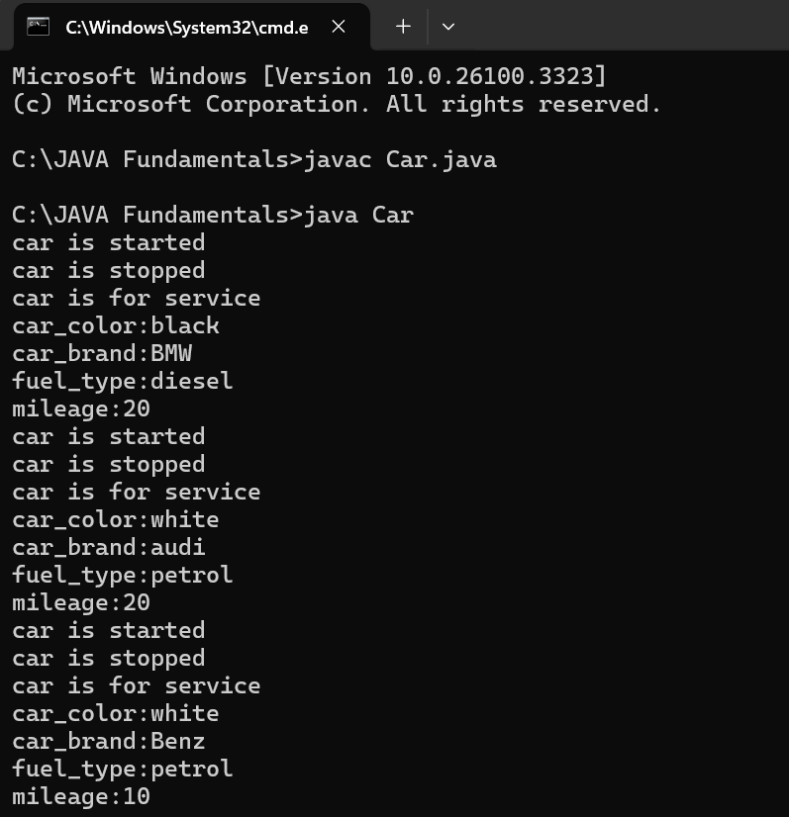

**Negative Output:**

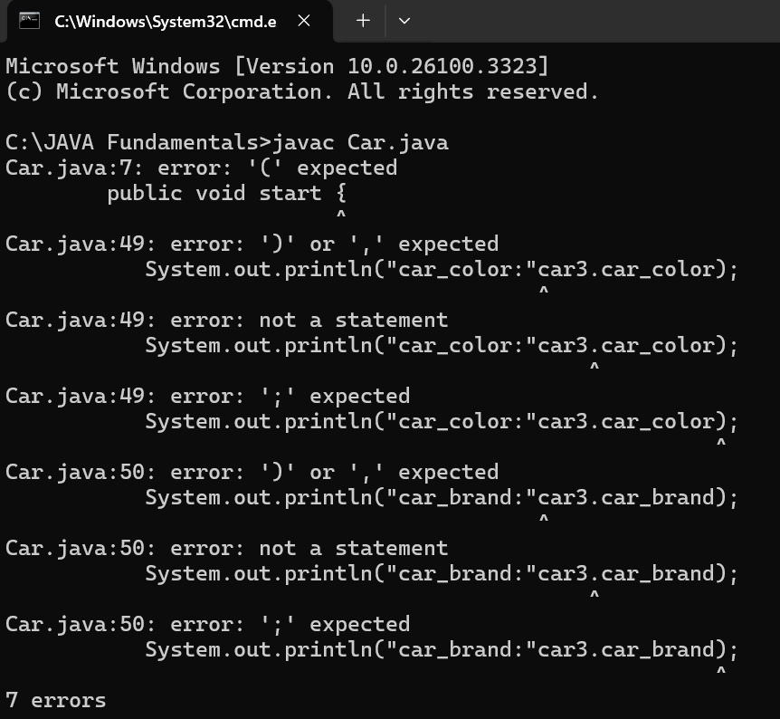

**IMPORTANT POINTS:**

The program defines a car class that represents a car's attributes and behaviors.

The class contains four attributes.

Three methods define car behaviors.

Three car objects (car1,car2,car3) are created with different attributes.

|  |  |
| --- | --- |
| Error Found | Error Rectified |
| Error: system.out.println  ^ in system ‘s’should be capital | Error rectified: System.out.println |

**Class Diagram:**

|  |
| --- |
| **Car**  **---------------------------**  **- car_color: string**  **- car_brand: string**  **- fuel_type: string**  **- mileage: double**  **---------------------------**  **+ start(): void**  **+ stop(): void**  **+ service(): void** |

**2)AIM-**

To create a class bankaccount with methods deposit() and withdrawl

**Code:**

public class BankAccount {

protected String accountHolder;

protected double balance;

protected int accountNumber;

public BankAccount(String accountHolder, int accountNumber, double balance) {

this.accountHolder = accountHolder;

this.accountNumber = accountNumber;

this.balance = balance;

}

public void withdrawal(double amount) {

if (amount <= balance) {

balance = balance-amount;

System.out.println("Current balance: " + balance);

} else {

System.out.println("Invalid withdrawal amount");

}

}

public void deposit(double amount) {

balance=balance+amount;

System.out.println("Current balance: " + balance);

}

public static void main(String[] args) {

BankAccount BA = new BankAccount("Maha", 24248, 10000);

BA.withdrawal(1000);

BA.deposit(1500);

}

}

**Positive Output:**

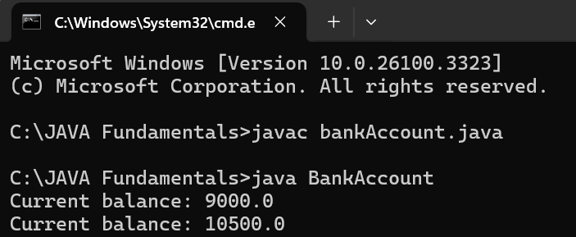

**Negative Output:**

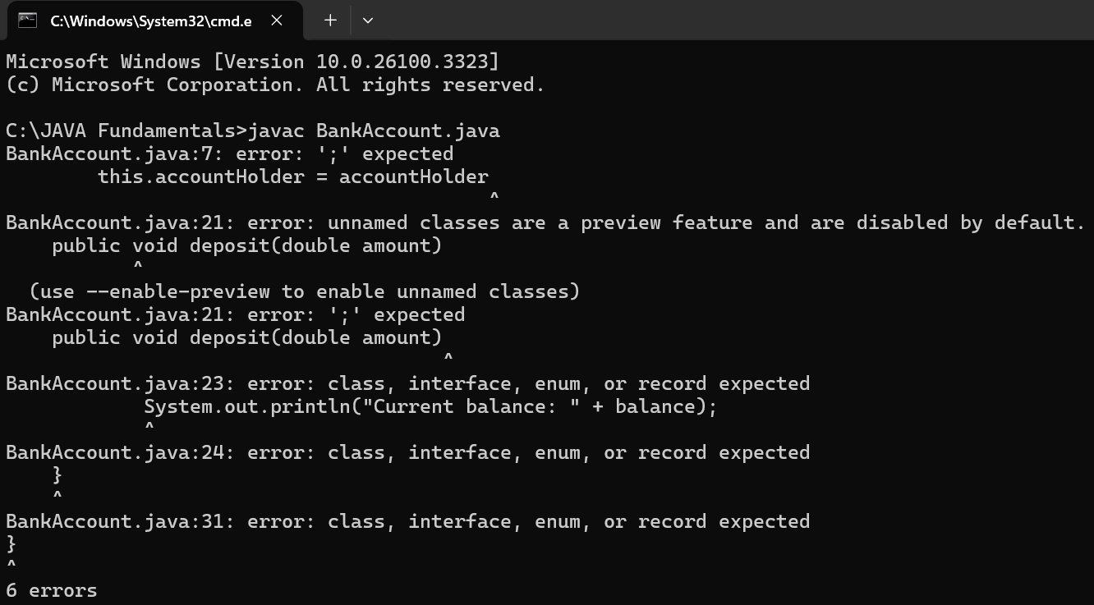

**IMPORTANT POINTS:**

The condition inside the if statement must be correct.

It explains that if the withdrawal money is less than the money in the bank account, then we can withdraw the amount.

|  |  |
| --- | --- |
| Error Found | Error Rectified |
| After Withdrawal,deposit not giving the parenthesis ( ). | 1. After every method, put the parenthesis ( ). |

**Class Diagram:**

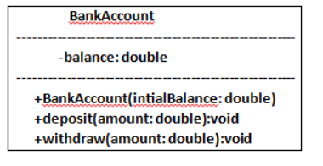

**WEEK-4**

**Program-1:**

**Aim:**

Write a java program with class named “book”, the class should contain various attributes such as title, author, year of publication it should also contain a constructor with parameters which initializes, title, author, and year of publication.

Create a method which displays the details of the book and display the details of two books.

**Code:**

class Book {

public String bookTitle;

public String bookAuthor;

public int bookYearOfPublication;

public void title() {

System.out.println("Book Title");

}

public void author() {

System.out.println("Book Year of Publishing");

}

public static void main(String[] args) {

Book book1 = new Book();

book1.bookTitle = "Harry Potter";

book1.bookAuthor = "J.K.Rowling";

book1.bookYearOfPublication = 1997-2007;

book1.title();

book1.author();

System.out.println("Book title is: " + book1.bookTitle);

System.out.println("Book author is: " + book1.bookAuthor);

System.out.println("Book year of publication is: " + book1.bookYearOfPublication);

Book book2 = new Book();

book2.bookTitle = "Think And Grow Rich";

book2.bookAuthor = "Napoleon Hill";

book2.bookYearOfPublication = 1937;

book2.title();

book2.author();

System.out.println("Book title is: " + book2.bookTitle);

System.out.println("Book author is: " + book2.bookAuthor);

System.out.println("Book year of publication is: " + book2.bookYearOfPublication);

}

}

**Positive Output:**

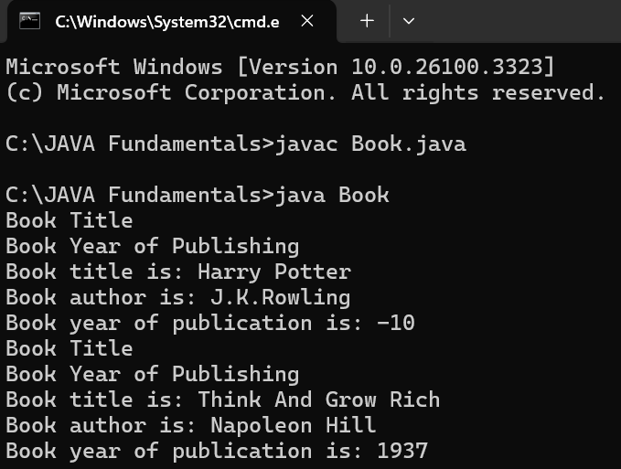

**Negative Output:**

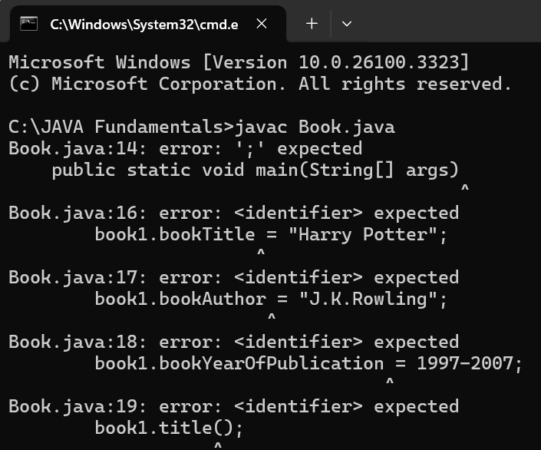

**IMPORTANT POINTS:**

While defining a method we should also define a function to call that method.

|  |  |
| --- | --- |
| Error Found | Error Rectified |
| Book.java:14: error: ';' expected  public static void main(String[] args)  ^ | public static void main(String[] args) { |

**Class Diagram:**

|  |
| --- |
| Book |
| -Title: String  - Author: String  -Year of publication: int |
| + Book(title: String,  Author: String;  Year of publication: int  + displayDetails( ): void |

**Program – 2**:

**AIM**:

Create a java Program with class named myclass with static variable count of int type, initialized to zero and a constant variable “pi” of type double initialized to 3.14 as attributes of the class, ow define a constructor for “myclass” that increments the count variable each time an object of my class is created (count++), finally print the final values of count and pi variables create three objects.

**Code:**

public class Myclass {

static int count = 0;

final double pi = 3.14;

public Myclass() {

count++;

}

public static void main(String[] args) {

Myclass obj1 = new Myclass();

Myclass obj2 = new Myclass();

Myclass obj3 = new Myclass();

System.out.println("count: " + count);

System.out.println("Value of pi: " + obj1.pi);

System.out.println("Value of pi: "+ obj2.pi);

System.out.println("Value of pi: " + obj3.pi);

System.out.println("Kanadam Sai Mahalakshmi");

}

}

**Positive Output:**

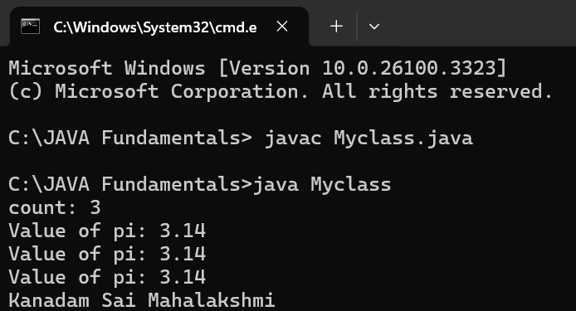

**Negative Output:**

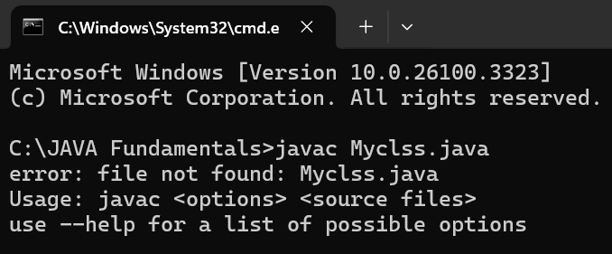

**IMPORTANT POINTS:**

We must declare the initial value of the variable before declaring the final one.

Here the main objective is to increase the count according to the number of objects we make, i.e the count increases when the no.of objects are increasing.

|  |  |
| --- | --- |
| Error Found | Error Rectified |
| Not giving the indentation properly. | All the indentation must be correct to run the code correctly. |

**Class Diagram:**

|  |
| --- |
| Myclass |
| * Count: int * Pi: double |
| + myclass( )  +main(args:String[]): void |

**WEEK-5**